Project Development Phase
Performance Test

Date | 15 February 2026
Team ID | LTVIP2026TMIDS77787
Project Name | Electric Motor Temperature Prediction using Machine Learning
Maximum Marks

Model Performance Testing:
Project team shall fill the following information in model performance testing template.
S.No. | Parameter | Screenshot / Values
 | Data Rendered | 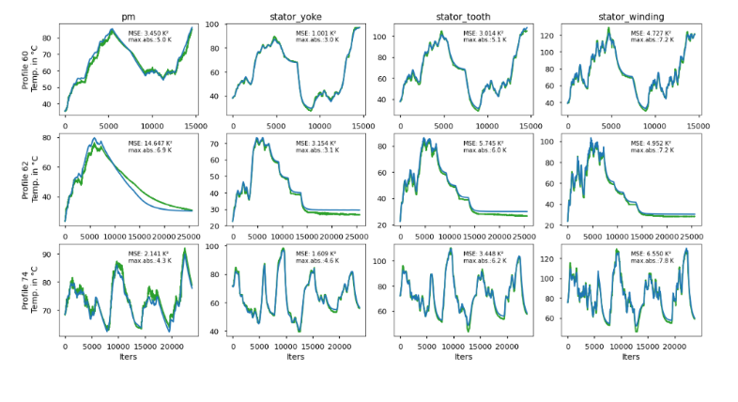  The motor sensor dataset containing pm, stator_yoke, stator_tooth, and stator_winding temperature profiles was successfully rendered into multiple visualizations. The dashboard displays actual vs predicted temperature trends across different iterations, enabling performance comparison.
 | Data Preprocessing | Before visualization, the dataset was cleaned by handling missing values and ensuring consistent formatting. The data was normalized to improve model stability and prediction accuracy. Preprocessing ensured reliable performance visualization.
3. | Utilization of Filters | Filters were utilized to isolate and analyze specific motor components individually. This allows detailed evaluation of prediction accuracy for each temperature profile such as pm, stator_yoke, stator_tooth, and stator_winding.
4. | Calculation fields Used | The following calculated performance metrics were used:  - Mean Squared Error (MSE)  - Maximum Absolute Error  - R² Score  These calculated fields help evaluate prediction accuracy and model efficiency.
5. | Dashboard design | No of Visualizations / Graphs -12  The dashboard contains 12 visualizations representing actual vs predicted temperature curves for multiple motor components. Each graph includes performance metrics such as MSE and maximum absolute error for better interpretability.
6 | Story Design | No of Visualizations / Graphs -12  The story design presents a structured flow starting from data rendering, followed by preprocessing, model prediction, and performance evaluation. The visual comparison between actual and predicted values clearly demonstrates the model’s predictive capability.

